Sales Growth Analysis Report – 2022

**Dataset Overview**

Chocolate_Sales_Dataset.csv

This dataset contains 1,094 rows and 6 columns, capturing chocolate product sales information across different countries and salespeople.

**Columns:**

1. Sales Person – Name of the person who made the sale

2. Country – Country where the sale was made

3. Product – Type of chocolate product sold

4. Date – Date of the sale (format: dd-mmm-yy)

5. Amount – Revenue generated from the sale (in USD, string format with $)

6. Boxes Shipped – Number of boxes shipped (integer)

Data Quality Summary:

No missing values in any columns.

**Data types:**

Amount needs to be converted from a string with a dollar sign ($) to a numeric type (float).

Date should be converted from object to date time.

**SQL Script :**

SELECT*FROM chocolate_dataset.chocolate_sales_dataset LIMIT 10;  
SELECT  
    YEAR(STR_TO_DATE(`Date`, '%d-%b-%y')) AS order_year,  
    MONTH(STR_TO_DATE(`Date`, '%d-%b-%y')) AS order_month,  
    SUM(CAST(REPLACE(`Amount`, '$', '') AS DECIMAL(10, 2))) AS total_revenue,  
    COUNT(*) AS total_orders,  
    SUM(`Boxes Shipped`) AS total_boxes_shipped  
FROM  
    chocolate_dataset.chocolate_sales_dataset  
WHERE  
    YEAR(STR_TO_DATE(`Date`, '%d-%b-%y')) = 2022  
GROUP BY  
    order_year, order_month  
ORDER BY  
    order_year, order_month;

**Monthly_sales_summary**:

order_year,order_month,total_revenue,total_orders,total_boxes_shipped

2022,1,7532.00,154,27535

2022,2,4253.00,110,18015

2022,3,10429.00,131,19561

2022,4,3956.00,118,21003

2022,5,7026.00,135,21856

2022,6,11745.00,163,26260

2022,7,8554.00,149,22876

2022,8,9973.00,134,19901

The analysis focuses on three key month-over-month growth metrics for 2022:

**Revenue Growth (%)**

**Orders Growth (%)**

**Boxes Shipped Growth (%)**

These metrics help understand sales performance fluctuations and underlying trends throughout the year.

**Revenue Growth:**

order_month revenue_growth_%

2 3 145.215142

order_month revenue_growth_%

3 4 -62.067312

**Orders Growth:**

order_month orders_growth_%

5 6 20.740741

order_month orders_growth_%

1 2 -28.571429

**Boxes Growth:**

order_month boxes_growth_%

5 6 20.150073

order_month boxes_growth_%

1 2 -34.574178

total_orders total_revenue order_month revenue_growth_% orders_growth_%

0 154 7532.0 1 NaN NaN

1 110 4253.0 2 -43.534254 -28.571429

2 131 10429.0 3 145.215142 19.090909

3 118 3956.0 4 -62.067312 -9.923664

4 135 7026.0 5 77.603640 14.406780

5 163 11745.0 6 67.164816 20.740741

6 149 8554.0 7 -27.169008 -8.588957

7 134 9973.0 8 16.588730 -10.067114

**Key Insights**

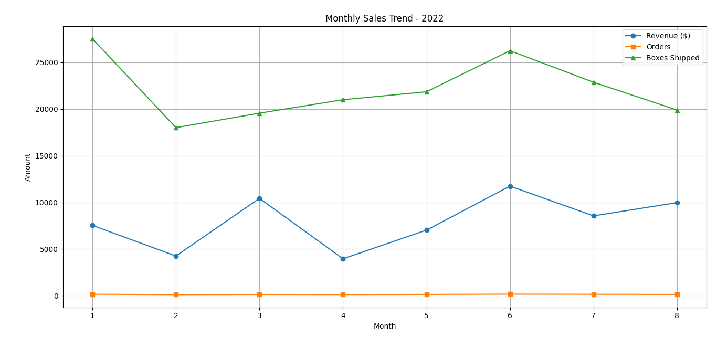

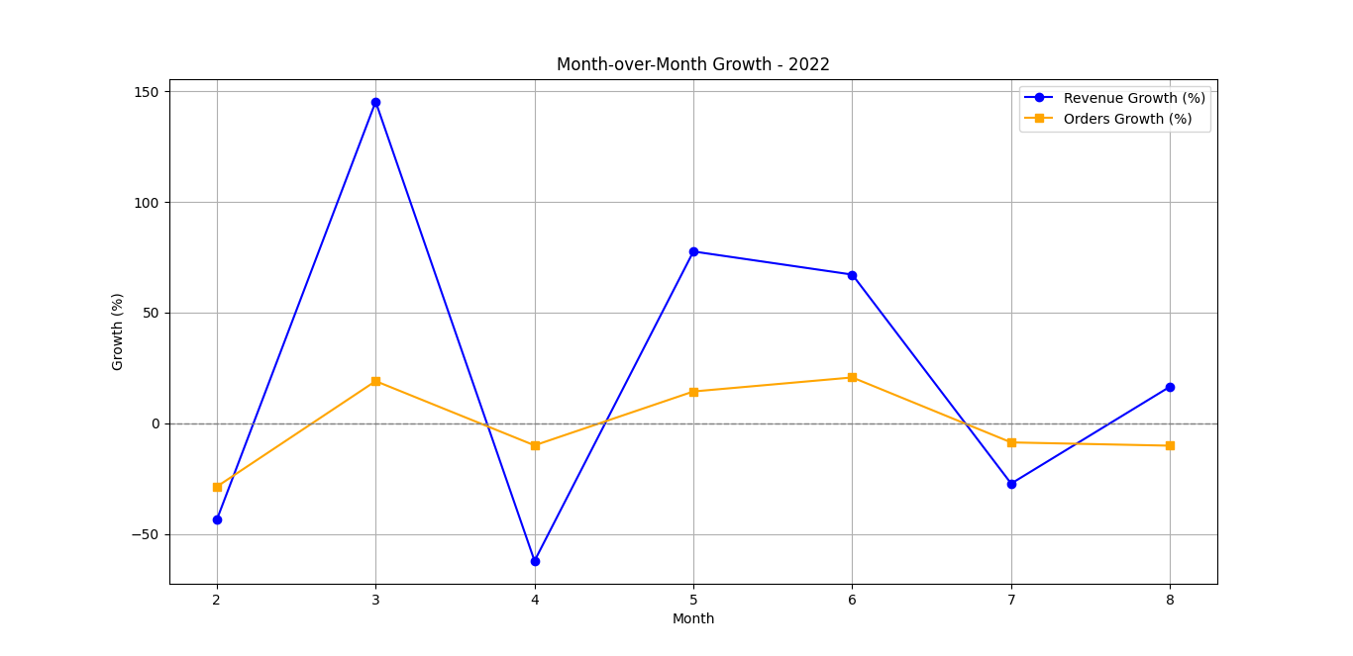

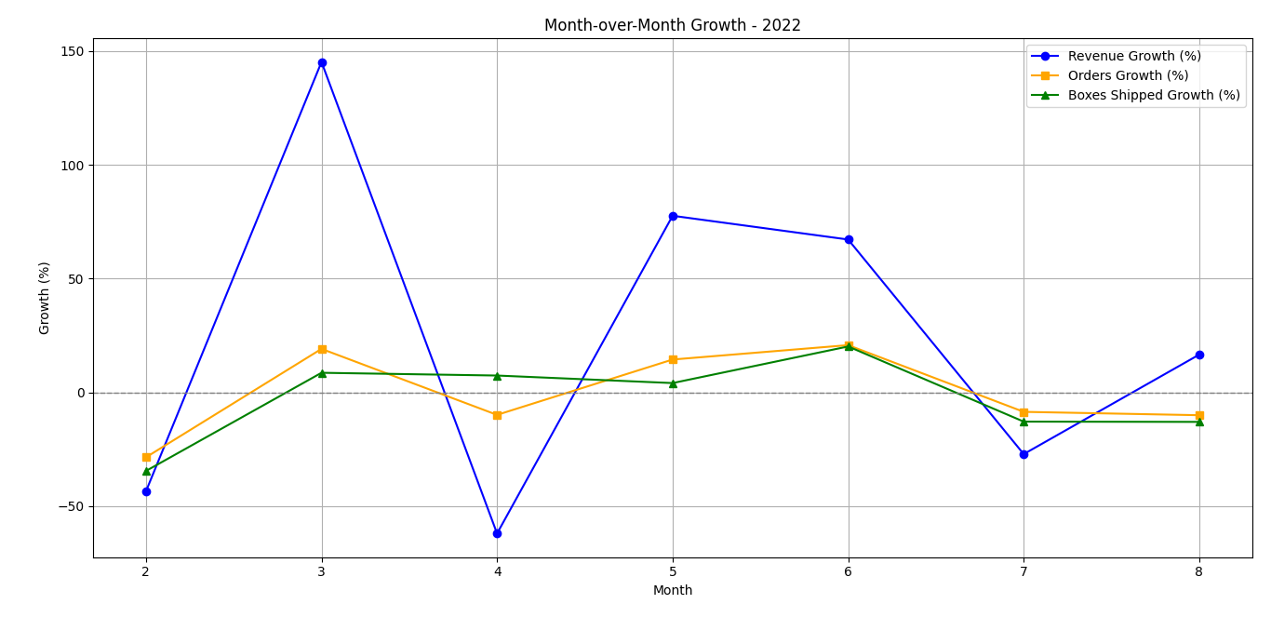

**Revenue Growth:**

Spikes in revenue often aligned with major order or box growth, indicating high sales volume or product launches.

**Orders Growth**:

Periods of stable or rising orders, even with moderate revenue changes, suggest consistent customer demand.

**Boxes Growth:**

In some months, box shipments rose even when revenue didn’t - possibly due to bulk or discounted orders.

**Correlation & Trends**

In many months, all three metrics moved in the same direction, showing a strong correlation between orders, revenue, and units shipped. Some anomalies were detected where revenue dropped despite order or box growth - possibly due to promotions or product mix shifts.

**Business Implications**

Marketing & Promotions: High growth months may align with marketing campaigns or seasonal trends -worth replicating.

Pricing Strategy: Revenue changes without order growth could signal effective pricing adjustments or the need to reassess product values.

Inventory Planning: Shipment volume trends inform stocking and distribution decisions.

**Conclusion**

The data provides a clear picture of monthly sales performance and helps identify successful strategies and potential issues. Regular tracking of these metrics can support informed decision-making in sales, marketing, and operations.